# **Projekti Inxhineri e Web-it**

**Eshte punuar nga :**

Shkurte Hoxha -> [sh51844@ubt-uni.net](mailto:sh51844@ubt-uni.net)

Vanesa Hoxha -> [vh53857@ubt-uni.net](mailto:vh53857@ubt-uni.net)

**GitHub Link:**

<https://github.com/ShkurtaH/webPageProject_>

**GitHub Screenshot:**

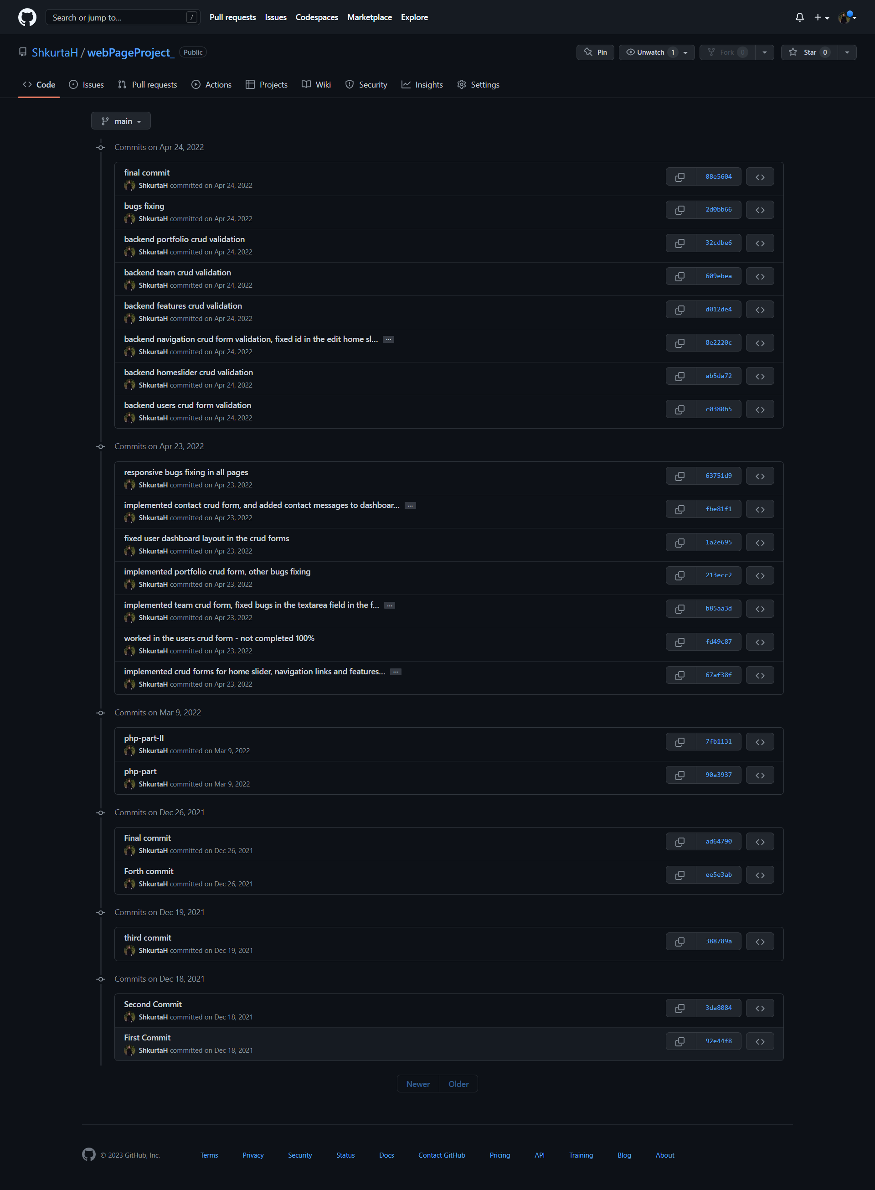**GitHub screenshot :**